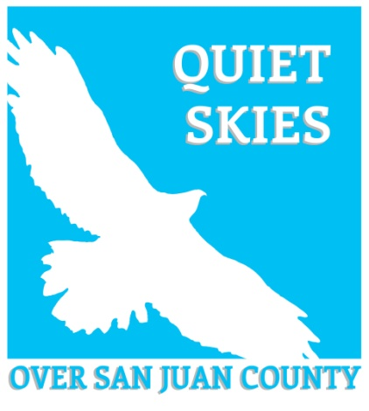
Update March 2021

Sign up. Registration for this is FREE!
Growler Jet Noise Science Symposium: Implications of Noise from Navy Aircraft for the Salish Sea and Olympic Region
March 16, 4-6pm. Free registration link is below.
San Juan County Marine Resources Committee (MRC) and the Salish Sea Institute at Western Washington University invite you to learn about navy jet noise and impacts to humans and wildlife in the region.
Lauren Kuehne and Rob Williams will present from recently published scientific research and a panel discussion will follow, moderated by Ginny Broadhurst, Director of the Salish Sea Institute, with opportunities for questions from the audience.
Registration information:
https://alumni.wwu.edu/event/salish-sea-science-symposium-implications-noise-navy-aircraft-salish-sea-and-olympic-region
Facebook event link: https://fb.me/e/ypfuOXI4
Please share widely with your networks.

Dr. Jill Biden to visit NASWI

First lady Jill Biden will visit two Washington military bases next week, her office announced. Dr. Biden will visit Joint Base Lewis-McChord and Naval Air Station Whidbey Island on March 9.
She is meeting with military families at the bases to hear about ongoing challenges they are facing during the pandemic.
While not the purpose of her visit, this is an opportunity to let the White House know how jet noise is impacting our community.
There is a form to contact the White House: https://www.whitehouse.gov/contact/

Latest Research on Jet Noise Impacts: Military Flights Threaten the Wilderness Soundscapes of the Olympic Peninsula, Washington

Noise from military aircraft over the Olympic Peninsula (Washington, USA), has increased in recent years with changes in operations from nearby facilities. Further increases in training activities are proposed, but lack of any data that describe current noise levels has hindered assessment of impacts on humans and wildlife. Over a one-year period, we monitored three primary and two supplemental sites to document current noise contributions of military aircraft to the soundscape. download
Military operations may result in noise impacts on surrounding communities and wildlife. A recent transition to more powerful military aircraft and a national consolidation of training operations to Whidbey Island, WA, USA, provided a unique opportunity to measure and assess both in-air and underwater noise associated with military aircraft. Read more at: https://www.mdpi.com/2077-1312/8/11/923

Report Jet Noise, PLEASE
Use the County’s website:
https://gis.sanjuanco.com/aircraft-noise-reporting
If you need help there are hints at: https://www.quietskies.info/access-the-county-report-site
You can also send an email to ask for help here: https://www.quietskies.info/contact-form

Also consider sending comments to the Navy: comments.naswi@navy.mil

