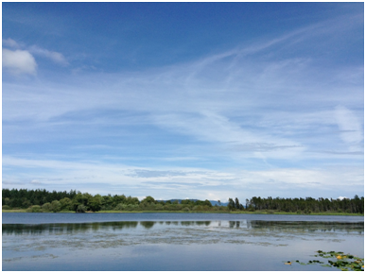
Quietskies
Over San Juan County

Update: April, 2015
Greetings,
The southern part of San Juan County has been immersed in another week of
relentless GROWLER noise - BUT, WE DO HAVE SOME GOOD NEWS.
STANLEY GREENTHAL'S SONG/VIDEO PROJECT IS MOVING ALONG. His song is aboutwhat it's like to live with constant Growler Noise. He calls it: "A
Sacrificial Zone." Stanley & Kip Greenthal have donated the initial start
up costs and Stanley is now working with Videographer Rowan North and
Photographers Steve Horn and Summer Moon. The Song/Video will not be sold
commercially and will be posted on the Quiet Skies website and other
related websites, sent to legislators, posted on Facebook and YouTube, and
distributed to news organizations with our story about how the Growlers
are impacting San Juan County and the region.
The whole project will cost about $3,500 - $4,000.
THE GOALS OF THE SONG/VIDEO PROJECT ARE:
1. We want to raise the awareness of how people in San Juan County are
being impacted by Navy Growlers. (Quality of life, Health, Economy,
Property Values.) We need to show that for many residents Growler noise is
not just an irritation. It's a health issue and it has changed our homes
from places of peace to places to endure.
2. To encourage the community to contact Representative Larsen, Senators
Cantwell and Murray and Governor Inslee and ask for immediate mitigation.
FUNDRAISING:
Quiet Skies is NOT a Non-Profit organization YET - (we're researching this
possibility). We have looked for an existing 501c3 Non profit organization
that would act as Fiscal Sponsor for tax deductible donations. At this
point we have not found an organization willing to provide an umbrella for
our Fundraising.
SO, MOVING FORWARD, we are asking donors to send donations (which will NOT
be tax deductible) to:
Stanley Greenthal
c/o Quiet Skies
P.O. Box 413
Lopez Island, WA 98261
Thank you for considering funding this project. Just today $600. has been
donated. We're off to a good start!
ANOTHER INVITATION: Quiet Skies wants to gather short 10 second (+ or -)
video clips of your jet noise experiences - they can be serious, funny,
whatever you want. They can show you gardening with ear protection or
???? They can show how the jets interrupt your phone calls or your dinner
or your sleep! We will edit the clips and put them together on our
website. Hopefully you'll send in lots and we can change them weekly. Send
your clips along to quietskiessanjuan@gmail.com
FINAL REMINDER:
Please continue to use the County Noise Website:
sjcgis.org/aircraft-noise-reporting/
This data belongs to San Juan County. The map is cleared monthly. We are
sending the data to our legislators, and the Navy. The surrounding
counties are looking for ways to duplicate what we have for their
residents. Regional participation will show the extent of the Growler
noise problem.
CHECK OUT THE ATTACHMENT BELOW TO SEE the 2167 noise complaints collected
April 16, 2014 to February 23, 2015.
REGIONAL GROWLER NEWS:
http://www.sequimgazette.com/opinion/292090181.html
http://www.ruralobserver.com/archive/Issue2015-03.pdf FROM CANADA
http://www.quietskies.info
http://westcoastactionalliance.org/
Northwest Washington residents are starting to to resist Navy expansion in
our region. Thanks to all of you who are helping!

