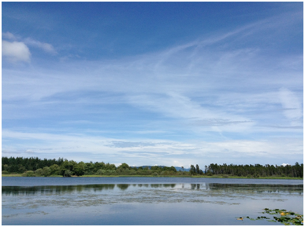
Quietskies
Over San Juan County

Update: June, 2015

This youtube video
(https://www.youtube.com/watch?v=aiWCA-X9ihM&feature=youtu.be)
speaks EXACTLY to the Growler jet noise issue facing the Olympic Peninsula
and to what San Juan County is already experiencing (minus the radiation).
If the Navy is successful in adding 36 Growlers to the Naval Air Station
on Whidbey Island and carrying out electromagnetic training over the
Olympic Peninsula, and the Straits of Juan de Fuca - the noise and impacts
will also increase over San Juan County.
****** More Growlers equal more Field Carrier Landing Practice (FCLP)
which affects the southern parts of SJC.
****** More Growlers equal more traffic landing at NAS Whidbey. Increased
traffic is shifted north over SJC bringing more noise and pollution.
The quiet natural sounds we treasure and our quality of life is threatened
by our supposed protectors.
https://www.youtube.com/watch?v=aiWCA-X9ihM&feature=youtu.be

WHAT CAN WE DO?
1. Inform ourselves.
http://westcoastactionalliance.org/
http://www.quietskies.info
2. Write to Representative Rick Larsen and Senators Maria Cantwell and
Patty Murray.
*** Ask Larsen, Murray and Cantwell for live Noise studies which include
the C scale (the signature noise of the Growlers) - not computer generated
ones averaged over 365 days per year.
*** Speak your concerns about the noise SJC already receives.
*** Speak your concerns about turning the Olympic Peninsula into an
Electromagnetic War Training Zone.
*** Speak your concerns about the effects of bombing and sonar on marine
life and the animal residents of the Olympic Peninsula and the San Juan
Islands.
3. Send your comments to our local papers.
SAN JUAN COUNTY IS NOW PART OF A REGIONAL RESISTANCE TO NAVY NOISE,
POLLUTION AND DEGRADATION OF ONE OF THE MOST PRISTINE ENVIRONMENTS IN THE WORLD.
LET'S DO OUR PART. Speak up!
PS: Lots of folks are wondering why the jets have been quieter -April, May
and June. We don't know. It could be related to seasonal wind changes,
keeping gear up over the islands, the Coupeville Injunction against the
Navy - it could also be that some of their training is happening
somewhere else as this video shows:
http://www.democracynow.org/2015/6/16/bombing_the_arctic_us_navy_war

